2019 Watch Night Service
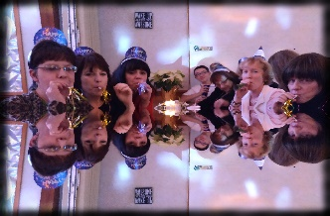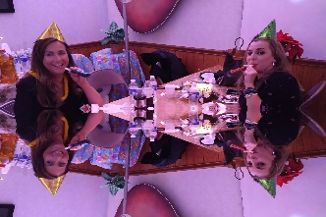
A time of great intimacy in Worship. The theme seemed to be: "To know him, to love him, to serve him, like never before". This will be our reality. He is requiring a complete surrender of our lives. Nothing must be held back.

He is going to surprise us. There will be a shock and awe of His glorious spender and power. The earth will experience the awesome reverential fear of the Lord. The Remnant church will become fully awake. He will do exceeding abundantly above all that we can ask or think (Ephesians 3:20). We're going to be so glad we didn't give up.

He said those that trust in him would never be disappointed. This has not always seemed to have been our experience. But we will now see this. This will be our reality.
Isaiah 49:23 "And kings shall be thy nursing fathers, and their queens thy nursing mothers: they shall bow down to thee with their face toward the earth, and lick up the dust of thy feet; and thou shalt know that I am the LORD: for they shall not be ashamed that wait for me.” He will watch over his word to perform it (Jeremiah 1:12). This is our Harvest Time; the time to reap that which we have been sowing in the spirit. ‬‬‬‬‬‬

He has prepared the way before us through our intercession and through our praise. He has made the crooked places straight, and now we will advance and go forward in what has been prepared in advance through our intercession and praise.

Tremendous Joy was manifest. This is a sign that the kingdom of God is here; righteousness, peace and joy. Romans 14:17 “For the kingdom of God is not meat and drink; but righteousness, and peace, and joy in the Holy Ghost.”‬

We drunk of the new wine. I kept hearing the book of Acts. (Acts 2:15-21) "These are not drunk as you suppose, but this is that which was spoken by the prophet Joel." Joel prophesied restoration! God will restore the years that have been stolen (Joel 2:25). Justice will begin to flow this year like powerful unstoppable rivers and streams.

We were led to pronounce a "Happy New Year" upon each other. "Happy" is the modern word for the Bible word, "blessed". We were told to command the blessing upon each other: "Happy New Year". "Blessed" New Year. The Lord said we had moved on from "seeking" the blessing, to now having the Lord "Command" the blessing upon us.

The numbers in 2019 add up to 12. 12 is the number of government. The Virgin bride; the church that is completely in love with the Lord and him alone, will give birth to the Man Child, the governmental sonship company (Revelation 12).

Tremendous love and joy were manifested tonight at the dinner and at the New Year's Eve gathering. This this a sign of things to come. Remember what Bob Jones said: "When the love of the brethren becomes a reality, we will see creative miracles."

When we left (sometime after midnight), tremendous winds and horizontal rain came through the region. I believe this points to the Winds of Change and the heavy rains in the Spirit which are coming this year (the latter rains which are 7 times more powerful than the former rains). This too is prophesied in Joel.

Joel 2:23 “Be glad then, ye children of Zion, and rejoice in the LORD your God: for he hath given you the former rain moderately, and he will cause to come down for you the rain, the former rain, and the latter rain in the first month. 25 And I will restore to you the years that the locust hath eaten, the cankerworm, and the caterpillar, and the palmerworm, my great army which I sent among you.” ‬‬‬‬‬

Let's make it our goal to draw closer to the Lord this year and to know Him more than ever. He is anointing us and blessing us as never before, to make us a blessing as never before.

Romans 8:21 "Because the creature itself also shall be delivered from the bondage of corruption into the glorious liberty of the children of God."‬

We haven't seen anything yet. The best is yet to come!

